Higher Applications of Maths Revision Booklet
Statistics Unit

Topic List
1. Data and Sampling
2. Graphical and Numerical Representations
3. Normal Distributions and Histograms
4. Correlation
5. Linear Regression
6. Hypothesis Testing

Some questions will require access to R studio. If you do this at home remember you can do so through Glow and the tile ‘Noteable’.

Section 1: Data and Sampling
1. Give two words to describe the data below.
(a) Height of a tree. Numerical and Continuous
(b) Genus of tree. Categorical and Nominal
(c) How much money a school spends in a year. Numerical and Discrete
(d) The number of staff employed. Numerical and Discrete
(e) Population of a country. Numerical and Discrete
(f) How many students pass a test. Numerical and Discrete
(g) What subjects a student does. Categorical and Nominal
(f) What position a player plays in. Categorical and Nominal
(h) The price of bread in a shop. Numerical and Discrete
(i) The weight of a salmon. Numerical and Continuous
(j) Cleanliness ratings from 1 to 5. Categorical and Ordinal

2. A survey is being done about S1’s experience in the first few weeks of term. A teacher asks their class. What in this example is the population and what is the sample? Population is all of S1 and the class is the sample.

3. A survey is done in a shop where they ask every 10th customer to fill in. What kind of survey is this? Systematic Sampling

4. If you asked all of S3 what the food in the canteen was like, what kind of sample is this? Cluster Sample

5. In a supermarket there are 80 Men employed and 120 Women. If you wanted to make a stratified sample of 40 employees how many of each gender should you ask?

80 + 120 = 200
80/200 x 40 = 16
120/200 x 40 = 24
16 Men and 24 Women

6. In a university there are 500 First years, 400 Second Years, 350 Third Year and 250 Fourth Years. If you did a stratified sample of 90 students, how many from each sub category should you ask?

Total = 1500
First Years 500/1500 x 90 = 30
Second Years 400 / 1500 x 90 = 24
Third Years 350 / 1500 x 90 = 21
Fouth Years 25 / 1500 x 90 = 15

Section 2: Numerical and Graphical Representation

From the following list of graphs and charts
- Bar Chart
- Line Graph
- Pie Chart
- Box Plot
- Scatter Plot
- Stem and Leaf Diagram

1. State a type of graph that would be suitable to display.

- The amount of people who voted for different political parties Bar Chart/Pie Chart
- People’s favourite genre of movie Bar Chart/Pie Chart
- The temperature throughout the week Line Graph
- Pupil’s weight against their height Scatter Plot
- How people get to work Bar Chart/Pie Chart
- A shop’s sale figures throughout the month of June Line Graph
- The temperature against how many people go to the cinema Scatter Plot

2. Calculate the mean and standard deviation of the following
60, 45, 72, 90, 83

3. The following graph shows show people get to work.
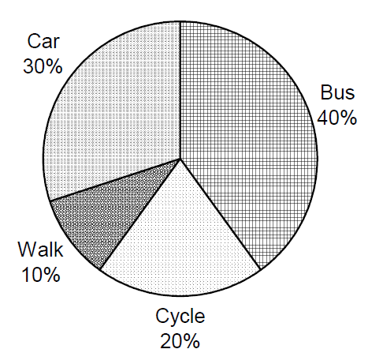
If 500 people were asked then how many said bus?
40% of 500 = 200

Section 3: Normal Distribution and Histograms

1. What 3 things can you to test if data is normally distributed?
Calculate the median and mode and see if they are close together
Create a histogram and see if the data is in a bell shape
Perform a Shapiro Test and see if p > 0.05

2. Draw the following Histogram and state if it is normally distributed or skewed.

Interval | Frequency
130 ≤ x < 140 | 2
140 ≤ x < 145 | 5
145 ≤ x < 150 | 15
150 ≤ x < 160 | 8
160 ≤ x < 175 | 9

3. Draw the following Histogram and state if it is normally distributed or skewed.

Interval | Frequency
0 ≤ £ < 20 | 40
20 ≤ £ < 30 | 50
30 ≤ £ < 40 | 55
40 ≤ £ < 50 | 40
50 ≤ £ < 100 | 50

4. Using the method discussed in question 1. Show if any of the following are normally distributed.

Age | 24 | 29 | 30 | 32 | 45 | 31 | 22 | 28 | 29 | 52 | 34 | 42
Height | 177 | 172 | 176 | 178 | 183 | 180 | 179 | 178 | 185 | 175 | 176 | 180
IQ | 99 | 102 | 110 | 105 | 104 | 98 | 97 | 105 | 125 | 114 | 106 | 104
Time to complete 1km | 350 | 280 | 260 | 325 | 310 | 290 | 300 | 330 | 360 | 390 | 360 | 320

Age:
> Age<-c(24,29,30,32,45,31,22,28,29,52,34,42)
> summary(Age)
Min. 1st Qu. Median Mean 3rd Qu. Max.
22.00 28.75 30.50 33.17 36.00 52.00

#Mean and median are relatively close together.

> hist(Age)

#Histogram does not appear to be bell shaped and instead looks like it is skewed to the right.

> shapiro.test(Age)

Shapiro-Wilk normality test

data: Age
W = 0.89852, p-value = 0.1518

#Since p is >0.05 this implies the data is in fact normally distributed.

Height:
> summary(Height)
Min. 1st Qu. Median Mean 3rd Qu. Max.
172.0 176.0 178.0 178.3 180.0 185.0
#Mean and median are relatively close together.

> hist(Height)

#Histogram does not appear to be bell shaped as the most results are not in the middle.

> shapiro.test(Height)

Shapiro-Wilk normality test

data: Height
W = 0.97943, p-value = 0.9629

#Since p is >0.05 this implies the data is in fact normally distributed.

IQ:
> summary(IQ)
Min. 1st Qu. Median Mean 3rd Qu. Max.
97.0 101.2 104.5 106.6 111.0 125.0

#Mean and median are relatively close together.

> hist(IQ)
#Histogram does not appear to be bell shaped and instead looks like it is skewed to the right.

> shapiro.test(IQ)

Shapiro-Wilk normality test

data: IQ
W = 0.90871, p-value = 0.2054

#Since p is >0.05 this implies the data is in fact normally distributed.

OneKm:

> summary(OneKm)
Min. 1st Qu. Median Mean 3rd Qu. Max.
260.0 297.5 322.5 325.4 352.5 390.0

#Mean and median are relatively close together.

> hist(OneKm)

#Histogram does not appear to be bell shaped, instead

> shapiro.test(OneKm)

Shapiro-Wilk normality test

data: OneKm
W = 0.9632, p-value = 0.8283

# Since p >0.05 this does imply the data is normally distributed.

Is there enough information to tell us if these variables are actually normally distributed.

Most likely not. Shapiro tests are unreliable unless there is a substantial amount of data.

Section 4: Correlation

1. State what each of the following correlation coefficients means.
(a) r = -0.8 Strong Negative Correlation
(b) r = 0 No correlation
(c) r = -0.28 Weak negative correlation
(d) r = 1 Perfect positive correlation
(e) r = 0.005 No correlation
(f) r = 0.62 moderate positive correlation

2. Input the following tables into R studio. Calculate the correlation coefficient and state what that means.

(a)
Year | 2002 | 2004 | 2006 | 2008 | 2010 | 2012 | 2014 | 2016 | 2018
Number of Cats | 70 | 46 | 57 | 78 | 32 | 67 | 90 | 45 | 40

> Year<-c(2002,2004,2006,2008,2010,2012,2014,2016,2018)
> Cats<-c(70,46,57,78,32,67,90,45,40)
> cor.test(Year,Cats)

Pearson's product-moment correlation

data: Year and Cats
t = -0.43243, df = 7, p-value = 0.6784
alternative hypothesis: true correlation is not equal to 0
95 percent confidence interval:
-0.7455568 0.5631460
sample estimates:
cor
-0.1613024
Weak Negative Correlation

(b)
Number of Bees Spotted (millions) | 4.5 | 6 | 2.5 | 1.1 | 1.9 | 4.7 | 5.2 | 3.1 | 5 | 7.8 | 1.1 | 0.75
Amount of Honey Produced (tonnes) | 600 | 700 | 400 | 190 | 200 | 650 | 710 | 450 | 715 | 900 | 140 | 90

> Bees<-c(4.5,6,2.5,1.1,1.9,4.7,5.2,3.1,5,7.8,1.1,0.75)
> Honey<-c(600,700,400,190,200,650,710,450,715,900,140,90)
> cor.test(Bees,Honey)

Pearson's product-moment correlation

data: Bees and Honey
t = 15.588, df = 10, p-value = 2.414e-08
alternative hypothesis: true correlation is not equal to 0
95 percent confidence interval:
0.9281946 0.9945560
sample estimates:
cor
0.9800376
Strong/Almost Perfect positive correlation

(c)
Number of cars on the road (millions) | 18 | 18.4 | 18.9 | 19.3 | 19.5 | 19.8 | 20.5 | 20.9 | 21.1 | 21.5 | 21.9 | 22.6
Average price of petrol that year | 1.34 | 1.36 | 1.4 | 1.45 | 1.40 | 1.51 | 1.32 | 1.58 | 1.77 | 1.68 | 1.70 | 1.8

> CarsRoad<-c(18,18.4,18.9,19.3,19.5,19.8,20.5,20.9,21.1,21.5,21.9,22.5)
> Petrol<-c(1.34,1.36,1.4,1.45,1.4,1.51,1.32,1.58,1.77,1.68,1.70,1.8)
> cor.test(CarsRoad,Petrol)

Pearson's product-moment correlation

data: CarsRoad and Petrol
t = 5.3292, df = 10, p-value = 0.0003334
alternative hypothesis: true correlation is not equal to 0
95 percent confidence interval:
0.5648889 0.9600562
sample estimates:
cor
0.8599899
Strong positive correlation

Section 5: Linear Regression

1. Look at the data below and input it into R Studio

Trees (thousands) | 925 | 882 | 750 | 640 | 590 | 540 | 420 | 390 | 350
CO2 Levels | 3.2 | 4.5 | 5.7 | 6.2 | 8.1 | 9.7 | 11.5 | 14.1 | 19.9

(a) Calculate the correlation coefficient between the number of trees and the CO2 levels.
> CO2Levels<-c(3.2,3.5,5.7,6.2,8.1,9.7,11.5,14.1,19.9)
> cor(Tree,CO2Levels)
[1] -0.9173174
Strong Negative Correlation
(b) Create an equation of linear regression and state it in the form y = mx + c
> lm(CO2Levels~Tree)

Call:
lm(formula = CO2Levels ~ Tree)

Coefficients:
(Intercept) Tree
23.56549 -0.02373
Co2 Levels = -0.02373(Trees) + 23.56549

(c) Create a line of best fit on R Studio
plot(Tree,CO2Levels)
abline(lm(CO2Levels~Tree))
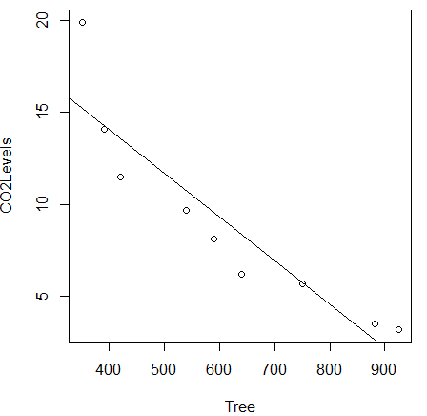
(d) Make a prediction about the CO2 levels if there were 200 (Thousand) trees.

> predict(lm(CO2Levels ~ Tree), newdata=data.frame(Tree=200))
1
18.82011

2. Look at the data below and input into R Studio.

Viewers of CL Final  (millions) | 305 | 309 | 312 | 308 | 315 | 330 | 350 | 317 | 360
No. of Amateur football teams  (thousands) | 1.25 | 1.28 | 1.31 | 1.32 | 1.35 | 1.38 | 1.39 | 1.44 | 1.45

(a) Calculate the correlation coefficient between the viewers of the champions league final and the number of amateur teams.
> CLFinal<-c(305,309,312,308,315,330,350,317,360)
> AFTeams<-c(1.25,1.28,1.31,1.32,1.35,1.38,1.39,1.44,1.45)
> cor(CLFinal,AFTeams)
[1] 0.7472319
(b) Calculate the equation of linear regression and state in the form y = mx + c
> lm(AFTeams~CLFinal)
Call:
lm(formula = AFTeams ~ CLFinal)
Coefficients:
(Intercept) CLFinal
0.509733 0.002609
No. of Amateur teams = 0.002609(Viewers of CL final) + 0.509733

(c) Create a line of best fit on R studio

> plot(CLFinal,AFTeams)
> abline(lm(AFTeams~CLFinal))
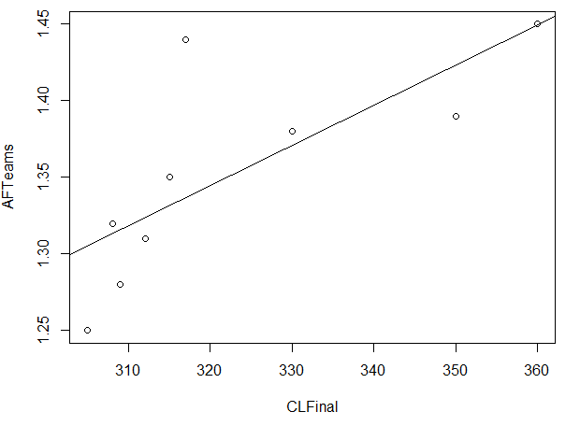

(d) Make a prediction about the number of Amateur football teams if the viewers of the champions league final was 400 (million).

> predict(lm(AFTeams~CLFinal), newdata=data.frame(CLFinal = 400))
1
1.553422

1553 teams

3. Look at the data below and input into R studio.

Distance from a volcano (miles) | 1.9 | 2.5 | 1.6 | 5.8 | 4.2 | 3.9 | 3.3 | 2.8 | 1.7 | 1.9 | 0.75 | 1.4 | 5.6 | 4.7
Amount of Tsunamis | 17 | 15 | 16 | 13 | 12 | 11 | 12 | 10 | 12 | 14 | 10 | 13 | 15 | 14

(a) Calculate the correlation coefficient between the distance from a volcano and the amount of Tsunamis.
> Volcanomiles<-c(1.9,2.5,1.6,5.8,4.2,3.9,3.3,2.8,1.7,1.9,0.75,1.4,5.6,4.7)
> Tsunamies<-c(17,15,16,13,12,11,12,10,12,14,10,13,15,14)
> cor.test(Volcanomiles,Tsunamies)

Pearson's product-moment correlation

data: Volcanomiles and Tsunamies
t = 0.11901, df = 12, p-value = 0.9072
alternative hypothesis: true correlation is not equal to 0
95 percent confidence interval:
-0.5054518 0.5548080
sample estimates:
cor
0.03433595

(b) Calculate the equation of linear regression and state in the form y = mx+ c

> lm(Tsunamies~Volcanomiles)

Call:
lm(formula = Tsunamies ~ Volcanomiles)

Coefficients:
(Intercept) Volcanomiles
13.00580 0.04563

No. of Tsunamis = 0.04563(Miles away from a Volcano) + 13.00580

(c) Create a line of best fit on R Studio

plot(Volcanomiles,Tsunamies)
abline(lm(Tsunamies~Volcanomiles))
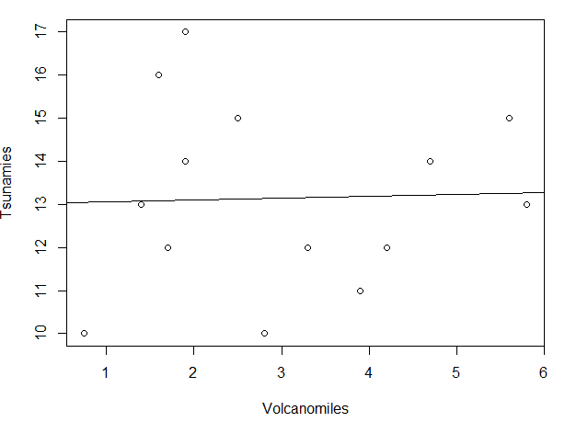

(d) Make a prediction about the number of Tsunamis that will have in a town 5.5 miles away from a volcano.

> predict(lm(Tsunamies~Volcanomiles), newdata=data.frame(Volcanomiles=5.5))
1
13.25677

Section 6: Hypothesis Tests

1. A gym record information about it’s customers and how often they go in the table below?
 | Age 16-24 | 15-30 | 30+
Once a week. | 70 | 110 | 308
Between 2 and 4 times a week. | 152 | 280 | 452
More than 4 times a week. | 8 | 29 | 3

(a) What kind of data is this information and what kind of test does it suggest we will use?
They are categorical which implies we use a Chi Square Test.

(b) State the null and alternative hypothesis.
H_{o} - There is no relationship between how old someone is and how often they go to the gym.
H₁ – There is a relationships between how old someone is and how often they go to the gym.

(c) Perform a statistical test and interpret these results.

GymAges<-matrix(c(70,110,308,152,280,452,8,29,3), nrow = 3, byrow=TRUE)
rownames(GymAges)<-c("Once a Week", "Between 2 and 4 times a week", "More than 4 times a week")
colnames(GymAges)<-c("Age 16-24", "15 - 30", "30+")
GymAges
chisq.test(GymAges)
Pearson's Chi-squared test

data: GymAges
X-squared = 61.053, df = 4, p-value =
1.743e-12

Since p < 0.05 we ject the null hypothesis and conclude that there is a relationship between someone’s age and how often they go to the gym.

2. Information about a drug being tested is below. There are two columns. The control group are not given the drug but instead a placebo, while the treatment are given a drug. Data about their average resting heart rate is included below.
Control | 90 | 81 | 124 | 110 | 96 | 91 | 82 | 117 | 109 | 84 | 72 | 84
Treatment | 110 | 112 | 98 | 128 | 124 | 118 | 119 | 120 | 82 | 95 | 100 | 103 | 75

(a) State the null and alternative hypothesis.
H_{o} – there is no difference in the heart rates of people on the control drug or the treatment drug
H₁ – There is a difference in the heart rate of people on the control drug and the treatment drug

(b) Assuming the data is not normally distributed state fully which kind of test you are going to use.
A 2 sample T Test (unpaired)

(c) Perform this test and interpret your results.
> t.test(Control,Treatment)

Welch Two Sample t-test

data: Control and Treatment
t = -1.7636, df = 22.805, p-value = 0.09119
alternative hypothesis: true difference in means is not equal to 0
95 percent confidence interval:
-24.912005 1.988928
sample estimates:
mean of x mean of y
95.0000 106.4615

Since p > 0.05 this means we cannot reject the null hypothesis and conclude that there might be no difference in the heart rates of people on the control drug or the treatment drug.

(d) How could this information be used?

To test if the drug is safe for people to use if they have a heart condition.

3. The amount of pollution in 8 cities across the UK is tracked. A program is produced to lower pollution slowly across 10 years, results are recorded below.

 | A | B | C | D | E | F | G | H
Year 0 | 12.3 | 11.1 | 15.6 | 13.5 | 14.2 | 16.3 | 17.3 | 14.2
Year 10 | 10.7 | 11.2 | 9.4 | 8.5 | 10.5 | 13.2 | 14.1 | 10.8

(a) State the null and alternative hypothesis
H_{o} – There is no difference in the amount of pollution 10 years apart.
H₁ – There is a difference in the amount of pollution 10 years apart

(b) Show if the data is suitable for a t test.

> summary(Year0)
Min. 1st Qu. Median Mean 3rd Qu. Max.
11.10 13.20 14.20 14.31 15.78 17.30
> summary(Year10)
Min. 1st Qu. Median Mean 3rd Qu. Max.
8.50 10.22 10.75 11.05 11.70 14.10
> hist(Year0)
> hist(Year10)
> shapiro.test(Year0)

Shapiro-Wilk normality test

data: Year0
W = 0.97979, p-value = 0.9619

> hist(Year10)
> shapiro.test(Year10)

Shapiro-Wilk normality test

data: Year10
W = 0.94101, p-value = 0.6211

Since mean and median is close together, the histograms are roughly bell shaped and both the shapiro wilks tess p values are > 0.05 then we can use a paired t test.

(c) Perform a hypothesis test and interpret your results.

> t.test(Year0,Year10, paired=TRUE)

Paired t-test

data: Year0 and Year10
t = 4.7918, df = 7, p-value = 0.001985
alternative hypothesis: true difference in means is not equal to 0
95 percent confidence interval:
1.652559 4.872441
sample estimates:
mean of the differences
3.2625

Since p < 0.05 then we can reject then ull hypothesis and conclude that there is a difference in the amount of pollution before and after the 10 years.

4. The height that people can jump in 2 gyms is recorded.
Gym 1 | 58 | 62 | 71 | 64 | 69 | 65 | 68 | 62 | 79 | 72 | 85 | 83 | 55 | 64 | 75 | 54 | 59 | 62 | 64
Gym 2 | 60 | 54 | 55 | 57 | 67 | 82 | 75 | 74 | 72 | 76 | 81 | 72 | 66 | 65 | 68 | 70 | 82 | 75 | 68

Stating the null and alternative hypothesis, perform statistical analysis to show if there is anything to show if people who can jump higher go to one gym or the other.
> summary(Gym1)
Min. 1st Qu. Median Mean 3rd Qu. Max.
54.00 62.00 64.00 66.89 71.50 85.00
> summary(Gym2)
Min. 1st Qu. Median Mean 3rd Qu. Max.
54.00 65.50 70.00 69.42 75.00 82.00
> hist(Gym1)
> hist(Gym2)
> shapiro.test(Gym1)

Shapiro-Wilk normality test

data: Gym1
W = 0.94469, p-value = 0.3197

> shapiro.test(Gym2)

Shapiro-Wilk normality test

data: Gym2
W = 0.95048, p-value = 0.4026

Since the data is normally distributed we are going to use a 2 sample t test

> t.test(Gym1,Gym2)

Welch Two Sample t-test

data: Gym1 and Gym2
t = -0.89607, df = 35.971, p-value = 0.3762
alternative hypothesis: true difference in means is not equal to 0
95 percent confidence interval:
-8.244334 3.191702
sample estimates:
mean of x mean of y
66.89474 69.42105

Since p > 0.05 this means we reject the null hypothesis and conclude that in all likelihood there is no difference in the amount people can jump in either Gym.

