Graphical Representations

You will have seen different graphs and charts before. You should be familiar with the creating and interpreting the following.
- Bar Chart
- Line Graph
- Pie Chart
- Stem and Leaf Diagram
- Scatter graph and line of best fit
- Boxplot

In the following series of lessons you will also be introduced to new graphs such as Histograms, along with new concepts such as Correlation and Normality.

Example 1: The following graph shows a baby’s weight throughout the year.
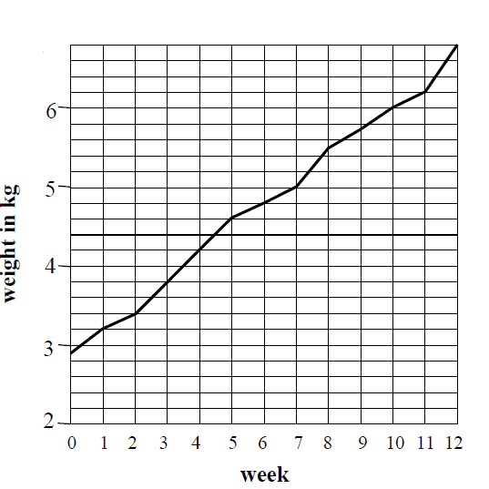
(a) What was the baby’s weight at birth?
2.9kg

(b) What did the baby weigh after 5,9 and 12 weeks?
5 weeks – 4.6kg
9 week – 5.7kg
12 weeks – 6.8kg

(c) How much weight did the baby put on between 3 and 7 weeks?
Week 3 – 3.8kg
Week 7 – 5kg

5 – 3.8kg

(d) Between which two consecutive weeks was the greatest increase in weight?
Weeks 11 and 12

Example 2: The following pie chart was made to show pupil’s favourite genre of film.
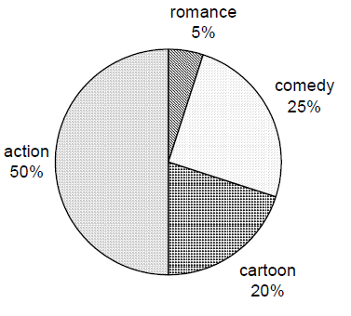
(a)What fraction of pupils chose each type of film?
Action: $\frac{1}{2}$
Comedy: $\frac{1}{5}$
Romance: $\frac{1}{20}$
Cartoon: $\frac{1}{5}$

(b) If 90 pupils said cartoons, how many pupils were asked in total?
20% = 90
100% = 450

For Higher Applications of Mathematics Excel and R Studio will primarily be used to create these charts and graphs however the important is being able to decide which type of graph is the most suitable in order to make conclusions on questions.

Example 3: A poll is taken of different votes in an area.
Blue | Red | Green | Yellow | Orange | Purple
3200 | 5000 | 2000 | 5800 | 1800 | 300

Input the table into Excel and decide what kind of charts are suitable and which are not.
State which kind of table you found suitable.
Suitable
Bar chart
Pie Chart

Not suitable
Line Graph
Box plot
Scatter plot

Example 4. The following shows the average attendance of a cinema in Glasgow throughout the first 12 weeks of the year which the number indicating the percentage of tickets sold in the median showing.
1 | 2 | 3 | 4 | 5 | 6 | 7 | 8 | 9 | 10 | 11 | 12
56 | 54 | 40 | 79 | 73 | 63 | 55 | 88 | 62 | 60 | 51 | 83

(a) Using Excel decide what type of graph is suitable, state which graph you have chosen and why?
Line Graph, they are good for comparing results over time.

(b) What does the information tell you about the attendance of cinema’s why do you think that is?
The results jump up every 4 weeks. This is because people are generally paid at the end of the month and so will have more money at that point.

(c) What kind of graph would be suitable to show the spread of the information?
Histogram?

Exercise: Drawing and Interpreting Graphs

1. The following bar chart shows the number of hours of sunshine for a week in April.
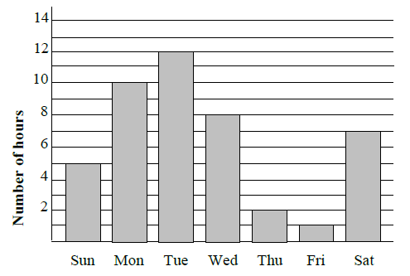
(a) Which day was the sunniest?
Tuesday
(b) Which day had 8 hours of sunshine?
Wednesday
(c) What was the total number of hours of sunshine over the weekend(Sat & Sun)
12 hours
(d) Which of the following would not be suitable?
Pie Chart, Line Graph, Box Plot, Stem and Leaf Diagram.
Box Plot, Stem and Leaf Diagram

2. Students were asked how they got to school. Their answers were made into a pie chart.

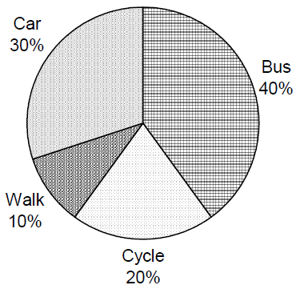
(a) What fraction said each of the answers?
Car 3/10
Walk 1/10
Cycle 1/5
Bus 2/5
(b) What was the least popular method?
Walk
(c) It turns out that the information for Train wasn’t included. 60 pupils said train. Given that 30 pupils said Walk, what should the percentages of all the methods of travel be?
Car = 25%
Walk = 8.3%
Bus = 33.3%
Cycle = 16.7%
Train = 16.7%

3. The line graph shows the average daily hours of sunshine in a holiday resort in low season.
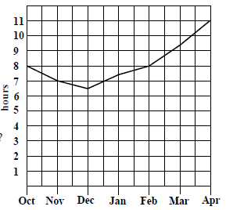
(a) Which month has the least hours of sunshine?
December
(b) What is the average daily hours of sunshine in April and December?
December – 6.5 hours
April – 11 hours
(c) How many more hours of sunshine are there in March than November?
March – 9.5
November – 7
Difference – 2.5 hours

4. The table below shows the destination of a class of pupils going on holiday.
Country | Scotland | England | Spain | France | Italy | USA
Number of pupils | 3 | 5 | 12 | 4 | 2 | 4
Create a graph that makes it easy to compare between the choices.

5. The table shows a patient’s temperature in ºC, taken a 2 hourly intervals for a 24 hours period.
Time | 0000 | 0200 | 0400 | 0600 | 0800 | 1000 | 1200 | 1400 | 1600 | 1800 | 2000 | 2200
Temp | 38.0 | 38.2 | 37.8 | 37.8 | 37.5 | 37.4 | 37.4 | 37.6 | 36.8 | 37.0 | 37.1 | 37.0
Create a graph that shows how the temperature changes with time.

Extension: You can input the data into an excel spreadsheet (remember to use a csv file) or type the data straight into R Studio. In R studio complete questions 4 onwards).

