Higher Application of Maths

Unit 4: Planning and Decision Making

Contents

Precedence Tables (N5 Recap) 3

Drawing Simple Precedence Tables 8

Activity Networks – PERT Charts 10

Drawing Activity Networks (Pert Charts) 17

Gantt Charts 20

# Precedence Tables (N5 Recap)

From National 5 Applications of Maths you should have looked at precedence tables such as the one below.

Example 1: Look at the table below and fill in the precedence table and state the critical path.

|  |  |  |
| --- | --- | --- |
| Task | Preceded by | Time (hrs) |
| A | None | 2 |
| B | None | 4 |
| C | A,B | 1 |
| D | C | 1 |
| E | D,F | 3 |
| F | C | 2 |

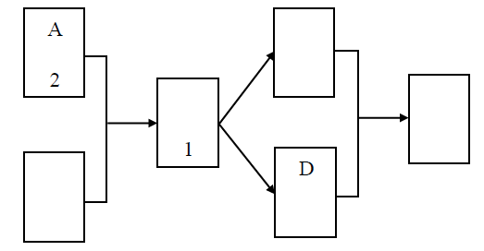

Example 2: The following shows the tasks that need to be completed for a garden to be cleaned up.

|  |  |  |  |
| --- | --- | --- | --- |
| Tasks | Detail | Preceding Task | Time minutes |
| A | Clear rubbish from the garden | None | 10 |
| B | Get lawnmower and edge shears out of the shed | None | 5 |
| C | Get hedge trimmer out of the shed | None | 5 |
| D | Cut grass in the garden | A,B | 30 |
| E | Trim edges of the lawn with shears | B,D | 10 |
| F | Cut the hedge | C | 20 |
| G | Put grass clippings in bag | D,E | 5 |
| H | Put hedge clippings in bag | F | 5 |
| I | Take bags to recycling centre | G,H | 45 |

1. Complete the chart below

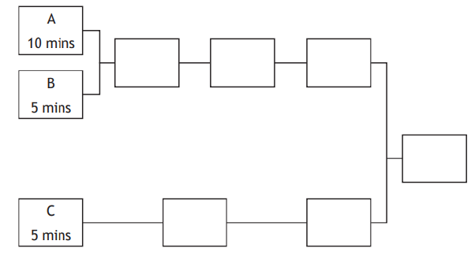

1. State the critical path and how long it would take the cut the grass.

|  |
| --- |
|  |

**Exercise: Precedence Tables (N5 Recap)**

1. The publishing company produced the following table to show all the tasks involved in publishing the book.

|  |  |  |
| --- | --- | --- |
| Activity | Description | Preceding Task |
| A | Illustrate cover | H |
| B | Write 1st draft | C |
| C | Research ideas | None |
| D | Edit book | B |
| E | Publish book | A,J,G |
| F | Re-work | D |
| G | Proof read | F |
| H | Choose title | B |
| I | Copyright | B |
| J | ISBN | I |

Complete the diagram below.

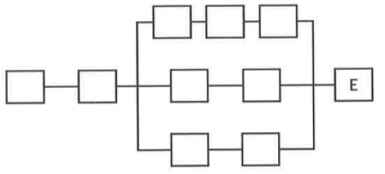

2. A factory produces cans of tinned beans. The table shows the list of tasks and the time taken to complete them.

|  |  |  |  |
| --- | --- | --- | --- |
| Task | Detail | Preceding task | Time (seconds) |
| A | Boil beans to cook them | C | 500 |
| B | Put on lid | H,E | 3 |
| C | Blanch dried beans in water | None | 300 |
| D | Attach label | I | 5 |
| E | Put sauce in tin | F | 2 |
| F | Make the sauce | None | 900 |
| G | Put in box | D | 5 |
| H | Put beans in tin | A | 2 |
| I | Cook beans in sauce tin | B | 300 |

(a) Complete the diagram below to show the tasks and times in the boxes.

The factory manager thinks that the whole process can be completed in less than 25 minutes.

(b) Based on the times given, is the factory manager correct?

3. Fence Direct provides a team of workers to build the fence. The table shows the list of tasks and the time taken to complete them.

|  |  |  |  |
| --- | --- | --- | --- |
| Task | Detail | Preceding Task | Time (hours) |
| A | Take the old fence | None | 2 |
| B | Measure length of fence needed | None | 0.5 |
| C | Mark on the ground where new posts must go | None | 0.5 |
| D | Collect materials and tools from yard | B | 1 |
| E | Hammer posts into the ground | A,C,D | 4 |
| F | Attach metal fencing to posts | E | 2 |
| G | Attach barbed wire to top of posts | F | 1 |
| H | Gather up rubbish | G | 2 |
| I | Gather up tools | G | 0.5 |
| J | Take rubbish to recycling centre | H | 1 |
| K | Put tools back in yard | I | 0.5 |

(a) Complete the diagram below by writing these tasks and times in the boxes.

(b) Fence Direct claims that all of these tasks can be completed in 10 hours. Is this a valid claim?

4. A computer company is researching how long it would take to develop a new games console and bring it to market.

The following table of necessary tasks was produced.

|  |  |  |  |
| --- | --- | --- | --- |
| Task | Description | Preceding Task | Time (months) |
| A | Product Testing | None | 12 |
| B | Market research | None | 2 |
| C | Production analysis | A | 3 |
| D | Product model | A | 4 |
| E | Sales brochure | A | 1 |
| F | Product testing | D | 5 |
| G | Cost analysis | C | 3 |
| H | Sales training | B,E | 2 |
| I | Pricing | H | 1 |
| J | Project report | F,G,I | 1 |

(a) Complete the diagram below to show the tasks and times in the boxes.

(b) The company want this entire process to be completed in 2 years. Based on the times given, is this possible?

5. The Clarks employ Kitease to install a new kitchen for them.

Kitease provide a team of workers to install the kitchen.

The table shows the lists and the time required for each.

|  |  |  |  |
| --- | --- | --- | --- |
| Task | Detail | Preceding Task | Time |
| A | Begin electrics | None | 3 |
| B | Build cupboards | None | 5 |
| C | Begin plumbing | None | 2 |
| D | Plaster walls | A,B,C | 8 |
| E | Fit wall cupboards | D | 6 |
| F | Fit floor cupboards | D | 5 |
| G | Fit worktops | F | 3 |
| H | Finish plumbing | G | 3 |
| I | Finish electrics | E,G | 4 |

(a) Complete the diagram below by writing these tasks and times in the boxes.

(b) Kitease claim they can install this kitchen in 22 hours. Is this a valid claim?

# Drawing Simple Precedence Tables

From this point on we will refer to precedence tables as Pert Charts. Pert stands for Project Evaluation and Review Technique.

When creating a PERT chart, project managers should follow the below steps:

Define all activities involved in the project.

1. Consider any dependencies between tasks.
2. Draw nodes and arrows based on the information gathered in the first two steps.
3. Identify the completion time for each task.

Once the PERT chart is drawn, project managers can use it to develop a realistic time frame for the project:

1. This can be done by finding the longest path, based on the estimations entered. This path should include the tasks that take the longest to complete.
2. By adding together the time it takes to complete each task, an estimation will be provided for how long the entire project will take.
3. Once this is done, the PERT chart can then be used to adjust the times if circumstances change or to ensure the project is finished by its designated deadline.

Example 1: Look at the following table that shows the steps for making a cake.

|  |  |  |
| --- | --- | --- |
| Activity | Description | Preceding Task |
| A | Gather Ingredients | None |
| B | Mix ingredients | A |
| C | Pre-heat Oven | None |
| D | Put mixture into cake tin | B |
| E | Bake cake in oven | C,D |
| F | Allow cake to cool | E |
| G | Prepare icing | E |
| H | Ice Cake | G,F |

Create a PERT chart to show the tasks above.

|  |
| --- |
|  |

Example 2. John employs a company to fit a new kitchen in his house. The company provide a team of workers to install the kitchen.

The table shows the list of all the tasks.

|  |  |  |
| --- | --- | --- |
| Task | Detail | Preceding Task |
| A | Begin electrics | None |
| B | Build cupboards | None |
| C | Begin Plumbing | None |
| D | Plaster walls | A,B,C |
| E | Fit wall cupboards | D |
| F | Fit floor cupboards | D |
| G | Fit worktops | F |
| H | Finish plumbing | G |
| I | Finish electrics | E,G |

Construct a Pert chart to illustrate this information.

|  |
| --- |
|  |

**Exercise: Drawing Simple Pert Charts**

1. The table lists the tasks needed to completely refurbish a kitchen, the times are given in days. Find both the critical path and the shortest completion time.

|  |  |  |  |
| --- | --- | --- | --- |
|  | Description | Time | Preceded By |
| A | Design Kitchen | 8 |  |
| B | Make kitchen units | 11 | A |
| C | Remove old units | 2 | A |
| D | Fit new power points | 1 | C |
| E | Fit new plumbing | 2 | C |
| F | Paint and decorate | 3 | D,E |
| G | Fit new units | 5 | B,F |
| H | Fix wall tiles | 3 | G |

2. Two friends are running a café. When a sandwich order comes in the tasks that need to be done are shown in the table below:

|  |  |  |  |
| --- | --- | --- | --- |
| Tasks | Detail | Preceding task | Time  (mins) |
| A | Get bread | none | 1 |
| B | Prepare side salad | none | 3 |
| C | Butter bread | A | 2 |
| D | Place filling on bread | C | 1 |
| E | Place sandwich on plate | D | 1 |
| F | Place salad on plate | B | 1 |
| G | Serve customer | E,F | 2 |

Create a PERT Chart to display this information.

# Activity Networks – PERT Charts

An activity network is designed to plan a task to take the least time.

When completing a project, some jobs will take less time than others, but have to be done in order.

An activity network can be used to determine the shortest time a project can take. This is an essential part of project management.

The **critical path** is a sequence of dependent tasks that determines the duration of a project. Tasks on the critical path need to happen for the project to finish, and they need to be done in a specific order. Tasks on the critical path will have a float of zero, meaning there are no delays in the sequence. There is no extra time to spare on these tasks, and if one is delayed, then the project is delayed too.

When completing these diagrams we are also going to be looking at activities **float time** this is the amount of time that activities can be delayed for without affecting when the entire project (or the critical path) will be completed.

Example 1. Look at the table below and complete the preceding diagram.

|  |  |  |
| --- | --- | --- |
|  | **Activity** | **Time** |
| A | Development of design | 4 |
| B | Detail product design | 8 |
| C | Specification and source of materials | 6 |
| D | Testing | 6 |
| E | Manufacture of components | 10 |
| F | Sub-assembly | 6 |
| G | Main Assembly | 8 |
| H | Finishing | 6 |

Step 1: Fill in the Activity Letters in the correct box with the time it takes for the activity in the middle box.

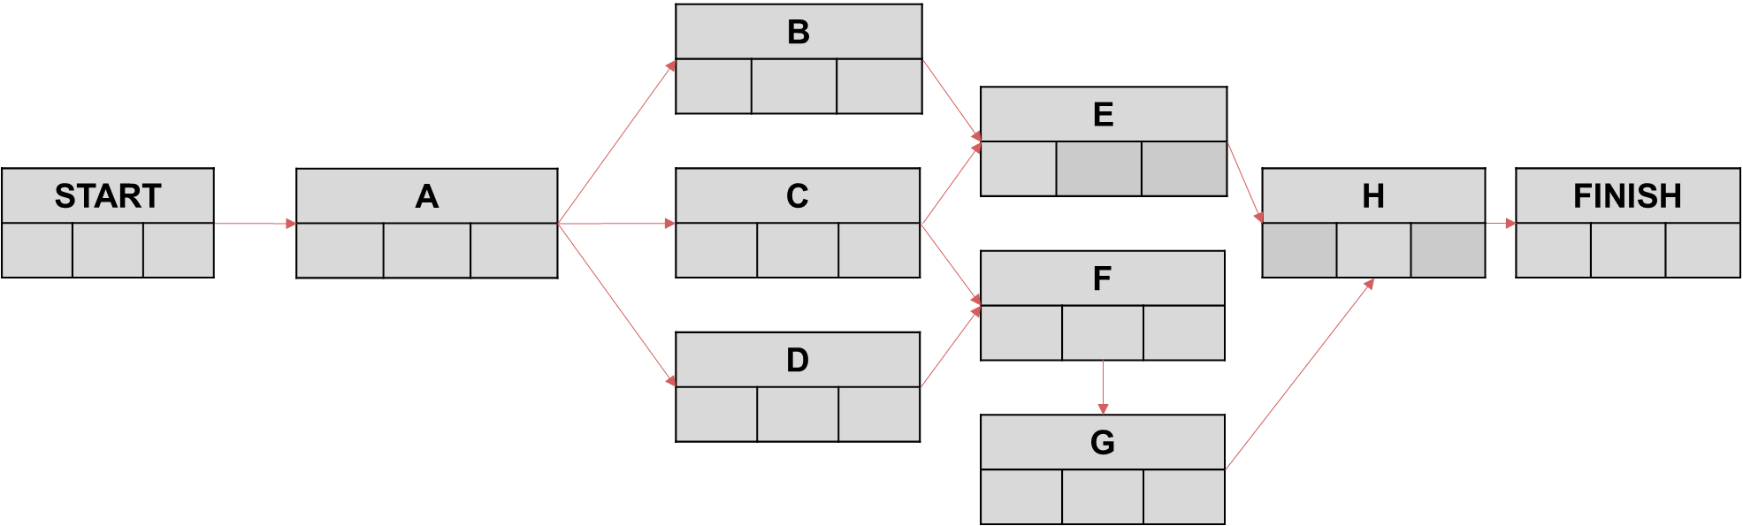

Step 2: Start on the left box. This box is for the **earliest start time** that an activity can have. So the first task which in this case is A will have an earliest start time of 0, so 0 will go in the left box. Since B,C and D cannot begin until A is finished, add A’s start time to its time taken (which is the middle box) and that will find the earliest start time for B,C and D. Continue until all the left boxes are completed. Remember an activity’s earliest completion time is when all the activities connected before it are completed. If an activity has no activities preceding it then its earliest start time is 0.

Step 3: The right box is the **latest completion time** that an activity can have so that it does not affect the final completion time. For this you begin on the final task and add it’s start time to the time it takes to complete. For boxes to the left of this (E,F and G) you subtract H’s time taken from it’s latest completion time. You continue to do this for each preceding task.

When you complete the table above your box for C should look like follows

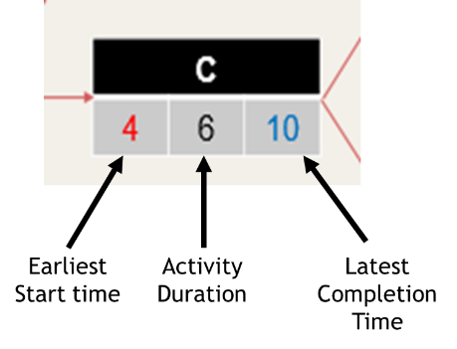

Once activity networks are filled in we can start looking at **float time**. This is the amount of time that you can delay a task so that there will be no delay to the final completion time. Meaning the critical path will be unaffected. If you look at task C above, it can’t start before 4, it takes 6 to complete and must be finished by 10. This means that it has no float time because it must be started right away in order for it to finish by 10 hours.

This can be used to find the critical path because any activities on the critical path will have **no float time.**

(b) What is the float time of activity E above

|  |
| --- |
|  |

(c) State the critical path of the activity network above.

|  |
| --- |
|  |

**Exercise: Activity Networks**

1. Complete the forward and backward scan for the following. The time given is in days.



State the critical path.

2. Look at the following activity node, given the time is in hours.

(a) State what each of the numbers in the activity node above means

(b) What is a critical path?

Look at the following PERT chart.



(c) Complete the PERT chart

(d) State the critical path and the number of hours required.

3. The following activity network diagram is used to plan a construction.



(a) What is the critical path of the project above?

(b) If the project started on 2 November, when would the earliest finish date be?

4. Look at the table below.

|  |  |  |
| --- | --- | --- |
| Activity | Time | Preceding Activities |
| A | 2.5 | None |
| B | 1.5 | A |
| C | 1 | A,B |
| D | 3 | A |
| E | 1 | C,D |

Complete the activity network below and state the critical path.



5. The following diagram shows an activity diagram for a building project. The time needed for each activity is given in days.

(a) Complete the activity network for the project stating the earliest start times and the latest finish times.

(b) Find the activity with the greatest float time and state the values of its float time.

6. The following table shows the steps required to make a roast dinner.

|  |  |  |  |
| --- | --- | --- | --- |
|  | Activity | Time | Preceding Task |
| A | Heat Oven | 10 | None |
| B | Put beef in the oven | 75 | A |
| C | Remove beef from the oven | 15 | B |
| D | Make gravy and simmer | 15 | B |
| E | Prepare vegetables | 15 | None |
| F | Parboil potatoes | 15 | E |
| G | Roast potatoes | 60 | E,F |
| H | Cook carrots | 20 | E |
| I | Cook cabbage | 3 | E |
| J | Put vegetables in dishes | 2 | G,H,I |
| K | Make batter | 5 | None |
| L | Heat oil in tin | 7 | None |
| M | Cook Yorkshire pudding | 25 | K,L |
| N | Serve meal | 5 | C,D,J,M |

Complete the pert chart below.



7. An activity network for installing a custom designed accounting system is shown below.

(a) Find the earliest start time for each activity.

(b) Find the latest finish time for each activity.

(c) What is the critical path of the activity network above?

(d) State the float times of activity B and D.

8. A painter and decorating business is planning a project. A PERT chart of the project is below.



(a) What is the critical path and how many hours?

(b) The company start work at 9am on Thursday 5 August. If they only work weekdays 9am to 2pm, what date and time will they likely finish the project if there are no delays?

(c) How many hours can Activity D be delayed without any effect on the timescale that everything can be completed.

9. A painting and decorating business is planning a project. A PERT chart of the project is below.



(a) What is the critical path and how many hours will it take?

(b) The company starts work at 9am on Tuesday 18 January. If they only work weekdays 9am to 3pm, what date and time will they likely finish the project if there are no delays?

# Drawing Activity Networks (Pert Charts)

Example 1: The following shows the steps involved to make a cake.

|  |  |  |  |
| --- | --- | --- | --- |
| Activity | Description | Preceding Activity | Time (in minutes) |
| A | Gather Ingredients | None | 5 |
| B | Mix ingredients | A | 2 |
| C | Pre-Heat oven | None | 15 |
| D | Put mixture into cake tin | B | 1 |
| E | Bake cake in oven | C,D | 20 |
| F | Allow cake to cool | E | 10 |
| G | Prepare icing | E | 5 |
| H | Ice Cake | G,F | 10 |

Complete a pert chart of the activities above.

|  |
| --- |
|  |

(b) State the critical path and how long it takes.

|  |
| --- |
|  |

Example 2:

Rhona employs a company to convert her loft into a living space.

The table shows the tasks required.

|  |  |  |  |
| --- | --- | --- | --- |
| Activity | Description | Preceding Activity | Time (days) |
| A | Make Staircase in workshop | None | 2 |
| B | On site preparation | None | 0.5 |
| C | Install floorboards | B | 1 |
| D | Install windows | B | 1 |
| E | Install floor covering | D | 0.5 |
| F | Install staircase | A,B | 0.5 |
| G | Decorate | C,D,F | 1.5 |
| H | Tidy Up | E,G | 0.5 |

(a) Complete the PERT chart to show the earliest possible start times and the latest possible completion times for this job.

|  |
| --- |
|  |

(b) The company starts the job on the 20th of April. On what date will the job be completed if there are no delays?

|  |
| --- |
|  |

**Exercise: Drawing and Completing Pert Charts**

1. A building project is being undertaken. The table shows the activities involved.

|  |  |  |
| --- | --- | --- |
| Activity | Predecessors | Duration (weeks |
| A | None | 2 |
| B | None | 1 |
| C | A | 3 |
| D | A,B | 2 |
| E | B | 4 |
| F | C | 1 |
| G | C,D,E | 3 |
| H | E | 5 |
| I | F,G | 2 |
| J | H,I | 3 |

(a) Complete an activity network for the project showing the earliest start time and the latest completion time.

(b) State the minimum completion time for the building project and identify the critical paths.

2. The following table shows the steps and times required to make a cup of coffee.

|  |  |  |  |
| --- | --- | --- | --- |
| Activity | Description | Duration | Preceding Task |
| A | Get cup and spoon | 15 | None |
| B | Fill kettle | 30 | None |
| C | Heat water | 60 | B |
| D | Put heated water in cup | 10 | A,C |
| E | Put coffee in cup | 10 | A |
| F | Put milk into cup | 10 | A |
| G | Put sugar into cup | 5 | A |
| H | Stir | 5 | D,E,F,G |
| I | Serve | 30 | H |

Draw a Pert Chart to show these activities.

3. The following table shows the tasks required in the construction of a Garage. The time is given in hours.

|  |  |  |  |
| --- | --- | --- | --- |
| Activity | Description | Duration | Preceding Task |
| A | Prepare Foundations | 7 |  |
| B | Make and position doorframe | 2 |  |
| C | Lay drains, floor base and screed | 15 |  |
| D | Install services and fittings | 8 | E |
| E | Raise walls | 10 | A,B |
| F | Plaster ceiling | 2 | D,G |
| G | Raise roof | 5 | E |
| H | Install door and windows | 8 | G |
| I | Fit gutters and house pipes | 2 | C,F |
| J | Paint Outside | 3 | I |

Draw a Pert Chart to display the information above and state the critical path.

4. A construction project is to be undertaken. The table shows the activities involved.

(a) Construct an activity network for the project.

(b) Find the earliest start time for each activity.

(c) Find the latest finish time for each activity.

(d) Find the critical path.

# Gantt Charts

A **Gantt chart** is a visual representation of a project and provides a timeline for a project, giving an overview of how a project is progressing. It allows project leaders to efficiently resource the project and keep a track of whether the task is on time.

The various project tasks are easy to see relative to one another, and the Gantt chart allows multiple users to see how the project is progressing over time and what steps or tasks are next.

An example of a Gantt chart is shown.

The chart shows:

* All the activities.
* When each activity begins and ends.
* The duration of each activity.
* Where activities overlap with other activities and by how much.
* The entire timescale of the project.

Example 1: Look at the table below

|  |  |  |  |
| --- | --- | --- | --- |
| Task | Description | Preceding Task | Time (minutes) |
| A | Gather ingredients | None | 15 |
| B | Mix ingredients | A | 5 |
| C | Preheat oven | None | 20 |
| D | Put mixture into cake tin | B | 5 |
| E | Bake cake in oven | C,D | 35 |
| F | Allow cake to cool | E | 15 |
| G | Prepare icing | E | 10 |
| H | Ice cake | G,F | 15 |

(a) Create a pert chart to display this information. Remember to show the earliest start time and the latest completion time.

|  |
| --- |
|  |

(b) Create a Gantt Chart to display this information.

|  |  |  |  |  |  |  |  |  |  |  |  |  |  |  |  |  |  |  |  |
| --- | --- | --- | --- | --- | --- | --- | --- | --- | --- | --- | --- | --- | --- | --- | --- | --- | --- | --- | --- |
|  |  |  |  |  |  |  |  |  |  |  |  |  |  |  |  |  |  |  |  |
|  |  |  |  |  |  |  |  |  |  |  |  |  |  |  |  |  |  |  |  |
|  |  |  |  |  |  |  |  |  |  |  |  |  |  |  |  |  |  |  |  |
|  |  |  |  |  |  |  |  |  |  |  |  |  |  |  |  |  |  |  |  |
|  |  |  |  |  |  |  |  |  |  |  |  |  |  |  |  |  |  |  |  |
|  |  |  |  |  |  |  |  |  |  |  |  |  |  |  |  |  |  |  |  |
|  |  |  |  |  |  |  |  |  |  |  |  |  |  |  |  |  |  |  |  |
|  |  |  |  |  |  |  |  |  |  |  |  |  |  |  |  |  |  |  |  |
|  |  |  |  |  |  |  |  |  |  |  |  |  |  |  |  |  |  |  |  |
|  |  |  |  |  |  |  |  |  |  |  |  |  |  |  |  |  |  |  |  |
|  |  |  |  |  |  |  |  |  |  |  |  |  |  |  |  |  |  |  |  |
|  |  |  |  |  |  |  |  |  |  |  |  |  |  |  |  |  |  |  |  |
|  |  |  |  |  |  |  |  |  |  |  |  |  |  |  |  |  |  |  |  |
|  |  |  |  |  |  |  |  |  |  |  |  |  |  |  |  |  |  |  |  |
|  |  |  |  |  |  |  |  |  |  |  |  |  |  |  |  |  |  |  |  |
|  |  |  |  |  |  |  |  |  |  |  |  |  |  |  |  |  |  |  |  |
|  |  |  |  |  |  |  |  |  |  |  |  |  |  |  |  |  |  |  |  |
|  |  |  |  |  |  |  |  |  |  |  |  |  |  |  |  |  |  |  |  |
|  |  |  |  |  |  |  |  |  |  |  |  |  |  |  |  |  |  |  |  |
|  |  |  |  |  |  |  |  |  |  |  |  |  |  |  |  |  |  |  |  |

Example 2: Complete the PERT chart below and draw a Gantt chart of the following.

Exercise: Gantt Charts

1. Produce a PERT and Gantt chart showing early and late times for this precedence table.

|  |  |  |  |
| --- | --- | --- | --- |
| Activity |  | Duration (minutes) | Predecessors |
| A | Briefing for candidates and agents | 20 | None |
| B | Ballot boxes arrive | 40 | None |
| C | Boxes opened and confirmed empty | 10 | B |
| D | Counting of in person ballots | 120 | C |
| E | Verification of ballots | 30 | B |
| F | Opening postal ballots | 30 | A |
| G | Counting postal ballots | 90 | F |
| H | Examination of spoiled papers | 15 | G,D,E |
| I | Confirmation of totals | 15 | H |
| J | Returning officer announces results | 10 | I |

2. Complete the PERT chart and draw a Gantt chart for the tasks below.

|  |  |  |
| --- | --- | --- |
| Task | Preceding task | Time |
| A | None | 3 |
| B | A | 4 |
| C | A | 7 |
| D | B | 2 |
| E | C | 1 |
| F | C | 6 |
| G | D,F | 3 |
| H | G | 2 |
| I | E,H | 1 |

3. A building company is planning to build a new hour. The table shows the list of tasks and time taken to complete them.

|  |  |  |  |
| --- | --- | --- | --- |
| Task | Description | Preceding task | Time |
| A | Create Plans | None | 2 |
| B | Prepare Site | None | 1 |
| C | Employ contractors | A,B | 1 |
| D | Create building site | A,B | 2 |
| E | Lay foundations | D | 1 |
| F | Build house | E | 6 |
| G | Building checks | E | 1 |
| H | Complete inside of house | F,G | 2 |
| I | Clear building site | H | 2 |
| J | Hand over building for sale | I | 1 |

Complete a PERT and Gantt chart.

4. Dan and his friends are planning a one-day music festival.

They have divided the work into a number of activities.

The table below shows

* The activities
* The immediate predecessors of each activity
* The number of days needed to complete each activity.

|  |  |  |  |
| --- | --- | --- | --- |
| Task | Activity | Preceding Tasks | Number of days |
| A | Choose and book the venue | None | 3 |
| B | Apply for a licence | A | 21 |
| C | Book musicians | B | 21 |
| D | Make publicity material | C | 20 |
| E | Print and give out flyers | D | 1 |
| F | Print tickets | B | 1 |
| G | Advertise on social media | D | 1 |
| H | Sell tickets | E,F,G | 10 |
| I | Organise transport and hospitality | C | 2 |
| J | Book food stalls | B | 1 |
| K | Prepare the venue | J | 7 |
| L | Hold the festival | H,I,K | 1 |

(a) Complete the activity network below.

(b) What is the critical path of this activity network

(c) Complete a Gantt chart to display these tasks.

5. A project manager is overseeing a software development project.

The table below lists the activities needed for this project, together with duration of each activity and the immediate predecessors for each activity.

|  |  |  |  |
| --- | --- | --- | --- |
| Task | Activity | Preceding Tasks | Number of days |
| A | Gather client requirements | None | 3 |
| B | Graphic design | A | 2 |
| C | User-interface design | A | 3 |
| D | Back end development | A | 4 |
| E | Front end development | B,C | 5 |
| F | Back end testing | D | 1 |
| G | Integration development | E,F | 6 |
| H | Legal certification | G | 1 |
| I | Documentation | G | 2 |
| J | Client acceptance testing | H,I | 3 |

(a) Complete the activity network below.

(b) State the critical path.

(c) Calculate the float on task F.

(d) Draw a Gantt chart.

6. Sandy is a builder. She is planning to renovate a conservatory for a customer. Some of the activities required for the project are listed below.

|  |  |
| --- | --- |
| A | Discuss plans with customer |
| B | Remove old fittings |
| C | Plaster walls |
| D | Order and collect doors and windows |
| E | Order and collect floorboards |
| F | Fit doors and windows |
| G | Lay floorboards |
| H | Paint walls, doors and windows |

Sandy draws a Gantt diagram below showing these activities.

(a) Complete the activity network below.

(b) State the critical path

(c) What is the latest possible start time for activity E?

7. After a passenger plane lands at an airport there is a limited amount of time to get the plane ready for its next flight.

The table shows the activities after a plane lands at an airport.

It also shows.

* The length of time taken for each activity.
* The earliest start time for each activity.
* The latest finish time for each activity.

|  |  |  |  |  |
| --- | --- | --- | --- | --- |
| Task | Activity | Length of time taken | Earliest Start Time | Latest finish time |
| A | Plane taxis from runway after landing | 12 | 0 | 12 |
| B | Arriving passengers disembark | 20 | 12 | 32 |
| C | Arriving luggage is taken from hold. | 30 | 12 | 48 |
| D | Plane is refuelled. | 18 | 12 | 42 |
| E | Rubbish is collected and trays wiped. | 10 | 32 | 42 |
| F | Departing luggage transported to hold. | 40 | 42 | 82 |
| G | Drinks and snacks trolley re-stocked. | 7 | 42 | 49 |
| H | Technical safety checks performed. | 30 | 42 | 92 |
| I | Departing passengers embark | 35 | 49 | 84 |
| J | Luggage hold checked and sealed | 4 | 82 | 92 |
| K | Passenger safety checks | 8 | 84 | 92 |
| L | Plane taxis to runway take off. | 12 | 92 | 104 |

(a) Draw a Gantt Chart to show this.

(b) Which activity has the largest float time?