Higher Applications of Maths Revision Booklet
Modelling and Statistics Assessment

Topic List
1. Linear Regression and Hypothesis Testing (R Studio)
2. Data
3. Units of Measurement
4. Fermi Estimations
5. Rate of Change
6. Type of Model
7. Plotting Equations in Excel
8. Recurrence Relations
9. Using Models
10. Interpreting Models

Some questions will require access to R studio. If you do this at home remember you can do so through Glow and the tile ‘Noteable’.

Section 1: Linear Regression and Hypothesis Testing

Question 1. For the following question use the Cholesterol_R csv file. Remember to set working directory. The data set refers to the Cholesterol before, after 4 weeks and after 8 weeks.

Cholesterol<-read.csv(“Cholesterol_R.csv”)
attach(Cholesterol)

(a) Construct a boxplots for before and after 8 weeks.
(b) Make two comments about your diagrams (median and range).
(c) Generate a statistical summary on your digital paper and comment on the differences between before and after 8 weeks.
(d) What assumption is made to conduct an appropriate hypothesis test for this data?
(e) State the null and alternative hypothesis.
(f) Use an appropriate statistical test to determine if there is a significant difference in the subjects Cholesterol before the study and after 8 weeks.

Question 2. For the following question use the airliners.csv. The data set is about planes length and wingspan.

(a) Using statistical software compute the correlation between the Length and Wingspan.
(b) What does this tell us about the relationship between the two variables.
(Strong/Weak negative/positive)
(c) Using statistical software create a scatterplot of the length on the x-axis and wingspan on the y-axis. Remember to add labels and a title.
(d) Using statistical software, show the coefficients of the linear model between length and wingspan. Write it in the form y = mx + c.
(e) Add a regression line on your scatter plot.
(f) Using statistical software and linear model to predict the length of a plane that is 38m long.

Question 3. For the following question use the bodyfat.csv data set. Compare the size of someone’s waist to their body fat percentage

(a) Using statistical software compute the correlation between the size of someone’s waist and their body fat percentage.
(b) What does this tell us about the relationship between the two variables?
(c) Using statistical software create a scatterplot of waist on the x axis and body fat percentage on the y axis.
(d) Using statistical software show the coefficients of the linear model between waist and body fat percentage and add a line of best fit to the scatter plot. Write the linear model in the form y = mx + c.
(e) Using statistical software and linear model to predict the body fat percentage of someone’s whose waist is 45 inches.

Question 4. For the following question use the cars data set. We are firstly going to analyse the if there is a relationship between engine size and co2 emission

(a) Construct a boxplots for engine size and after co2 emission.
(b) What assumption is made to conduct an appropriate hypothesis test for this data.
(c) State the null and alternative hypothesis.
(d) Use an appropriate statistical test to determine if there is a significant difference between engine size and co2 emissions.
(e) Is this a significant result? What does it tell us?

Question 5. For the following question use the fare data set. The data set is about the relationship between fare and distance of a taxi journey.

(a) Using statistical software compute the correlation between the distance travelled in a taxi and a fare.
(b) What does this tell us about the relationship between the two variables.
(c) Using statistical software create a scatterplot of distance on the x axis and fare on the y axis.
(d) Using statistical software show the coefficients of the linear model between the distance and fare and add a line of best fit to the scatter plot.
(e) Using statistical software and linear model to predict the fare for a journey of 30 miles.
(f) What are the limitations of this model?

Question 6. For the following question use the birdsvscaptivity.csv data set. The data set is about the age birds live to in the wild against birds that live in captivity

(a) Construct a boxplots for wild and captivity..
(b) What assumption is made to conduct an appropriate hypothesis test for this data.
(c) Use an appropriate statistical test to determine if there is a significant difference between age birds live to in the wild and in captivity.
(d) Is this a significant result?

Section 2: Data
1. Give two words to describe the data below.
(a) Height of a tree.
(b) Genus of tree.
(c) How much money a school spends in a year.
(d) The number of staff employed.
(e) Population of a country.
(f) How many students pass a test.
(g) What subjects a student does.
(f) What position a player plays in.
(h) The price of bread in a shop.
(i) The weight of a salmon.
(j) Cleanliness ratings from 1 to 5.

Section 3: Units of Measurement
1. A formula is given as,
$$T= \frac{2πr}{v}$$
Where r is measured in meters, and v is measured in meters per second. Find the unit T.

2. A formula is given as,
$$ρ= \frac{F}{A}$$
Where F is measured in Newtons (N) and A is measured in square meters. Find the unit for measuring pressure$ρ$.

3. A formula is given as,
$$s=ut+\frac{1}{2}at^{2}$$
Given u is measured in meters per second and t is measured in seconds.
(a) Find the base unit of ut.
Given a is measured in meters per second squared and t is measured in seconds,
(b) Find the base unit of ½ at²

4. A formula is given as,
$$M=mg$$
m is measured in kg and g is measured in meters per second squared.

Section 4: Fermi Estimations
1. How many pensioners are there in the UK?
2. How many buses would you need to fit all the pupils in this school on?
3. How many people could you fit in a maths classroom?
4. How much money will be spend on Christmas presents in the UK this year?
5. Estimate the number of hours a typical person spends eating in their lifetime.
6. Estimate the number of traffic cones you can fit on a football pitch.

Section 5: Rate of Change
1. For the graph below calculate the average rate of change for the first 5 seconds.
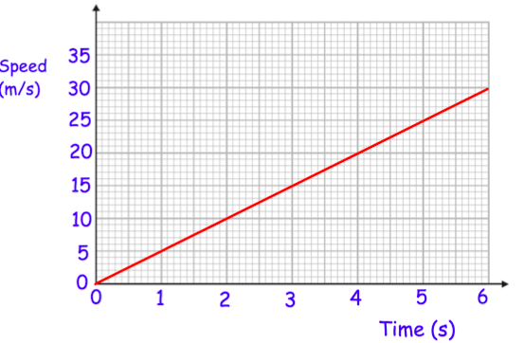
2. For the graph below calculate the average rate of change for the first 12 seconds.
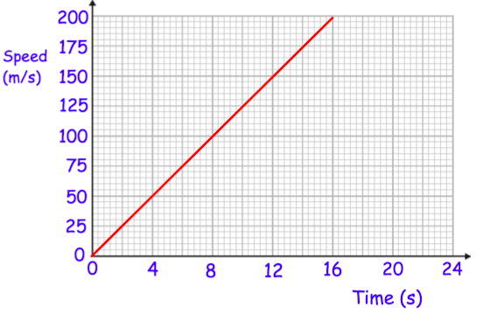
3. A rocket is fired upwards as part of a science experiment.
The graph shows the height of the rocket above the ground.

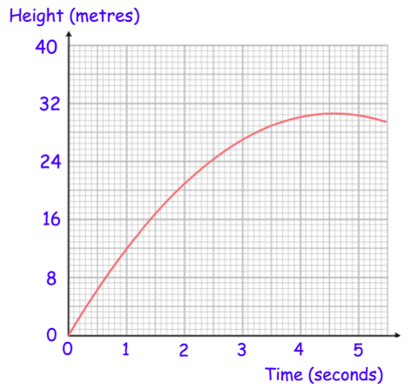
Calculate the average acceleration between 1 and 4 seconds.

4. Below is the velocity-time graph of a car journey.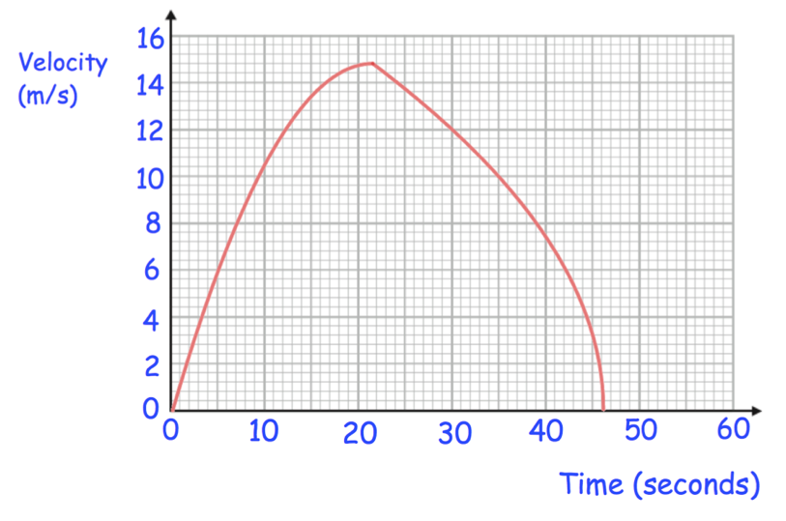
(a) Work out the acceleration over the first 20 seconds of the journey.
State the units of this acceleration.
(b) Estimate the deceleration of the car in the final 6 seconds.

5. The graph shows the distance travelled by a train over 36 seconds.
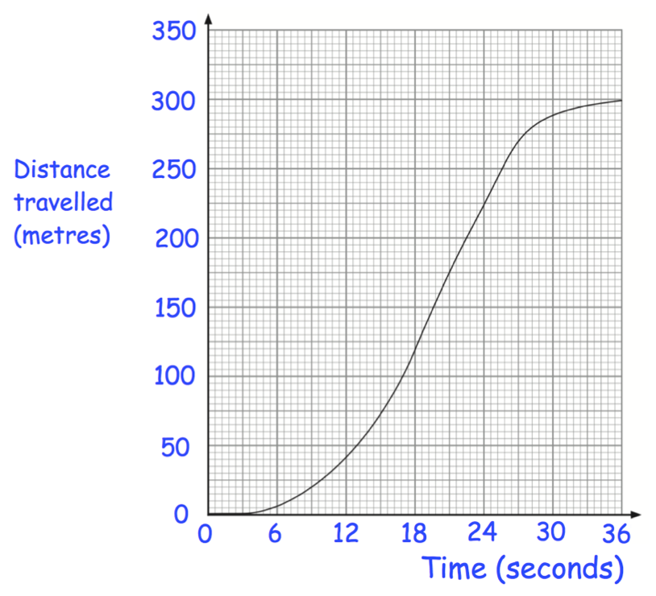
(a) Work out the average acceleration of the train between 6 and 18 seconds.
(b) Estimate the average acceleration of the train over the last 9 seconds.

6. In 2009, Usain Bolt set a world record of 9.58 seconds for the 100 metre sprint.
(a) Calculate Bolt’s average speed when he set this world record.
The graph below shows the speed v in metres per second, against time, t, in seconds at 10 metre intervals during this race.
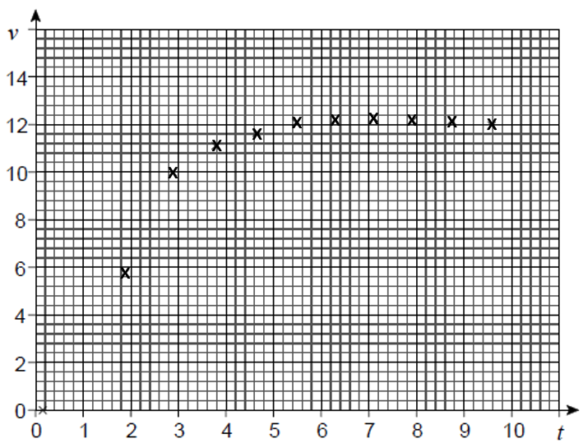
The linear equation below models Bolt’s speed, v, in metres per second, against time, t, in seconds, during the first 3 seconds of the race.
v = 3.62t – 0.663
(b) Calculate Bolt’s acceleration during the first 3 seconds of the race.
(c) Describe how Bolt’s acceleration varies during the rest of the race.

Section 6: Type of Model

State what type of function each of the following is.

1. y = 4x – 3
2. y = x² – 9x + 15
3. y = e^{4x}
4. y = 5^{-0.5x}
5. y = 4 – 2x
6. y = 14 – x²
7. y = 5
8. y = 2^{0.1x}
9. y = e^{-5x}
10. y = 4x² + 5x + 2

Section 7: Plotting equations in Excel

1. The population of a small town is growing by 10% every 5 years. Initially the population is 1000 people.
(a) Plot of graph of y = 1.1x, for 0 ≤ x ≤ 8.
(b) Use the graph/table to calculate how many years it takes for the population to double.

2. An investment of £500 grows at an annual rate of 2.5%.
(a) Plot a graph of y = 500(1.025^{x}) use the values of x from 0 to 30.
(b) How many years does it take for the investment to double in value?

3. The table below shows the world population from 1AD to 2020.

Year | 1 | 1000 | 1500 | 1650 | 1750 | 1850 | 1900 | 1950 | 2000 | 2020
Billions | 0.2 | 0.275 | 0.45 | 0.5 | 0.7 | 1.2 | 1.6 | 2.55 | 6 | 7.8

(a) Which axis should population go on?
(b) Plot the data above in Excel
(c) Add a line of best fit and decide if it should be linear or exponential. Write the equation of your line of best fit and give justification for your type of model.
(d) Can you think of any limitations to your model?

4. An oil spill in increasing in size. The table shows the width of the spill in meters and its area in square meters.
Width w | 1 | 2 | 3 | 4 | 5 | 6
Area | 1 | 3.5 | 8 | 14.5 | 22.5 | 32.5
(a) Plot a graph of A against w on excel and add a line of best fit.
(b) Add a column to excel called w², then calculate these values.
(c) Plot a graph of A against w², add a line of best fit.
(d) Write the equation of your line of best fit.

5. An equation has the formula
Y = -1.53x + 29.5
(a) Make a table in Excel for all the points
(b) Approximately when does the line reach the x axis?

6. The height h of a ball thrown upwards is calculated using the formula
h(t) = 30t – t², where t is the time in seconds after the ball is thrown.
(a) State what the dependent and independent variable are.
(b) Produce a graph of this quadratic using excel.
(c) State the time that the ball reaches its highest point.

7. The diagram below shows the path of a small rocket which is fired into the air. The height h meters of the rocket after t seconds is given by

h(t) = 16t – t²

(a) What type of model is this?
(b) Find the maximum height of the rocket.
(c) After how long will the rocket come back to the ground.

8. Electricity on a spacecraft can be produced by a type of nuclear generator.
The electrical power produced by this generator can be modelled by.
$$P_{t}=120e^{-0.0079t}$$
Where P_{t} is the electrical power initially produced by the generator.
(a) State the dependent and independent variable.
(b) Determine the electrical power initially produced by the generator.
(c) Calculate how long it takes for the electrical power produced by the generator to reduce by 15%.

9. Scientists are studying the growth of a strain of bacteria. The number of bacteria present is given by the formula
B(t) = 200e^{0.107t}
Where t represents the number of hours since the study began.
(a) State the number of bacteria present at the start of the study.
(b) Calculate the time taken for the number of bacteria to double.

10. A small meteor passes through a dust shower. It picks up particles and gains weight (kg) in time (hours) according to the expression W_{t} = 1.2e^{0.06t}.
(a) what was the initial weight of the meteor.
(b) How long will it take for the meteor to double in weight.

11. The profit of a company is modelled as,
P = 100.2Y – 1500
Where P is profit in pounds and Y is years.
(a) On Excel show the results from 2010 to 2020.
(b) How long will it take for the profit to reach £202000

12. The amount of algae in a lake is modelled by the formula
$$N=1.9e^{0.4D}$$
N is the number of algae. D is the number of days.
(a) Create a table in Excel for the first 10 days.
(b) How long will it take for the number of algae to reach 25000.

13. Veronica posts an interesting video on Facebook.
The total number of views, N, at time t hours after the video was first viewed is modelled by
$$N=e^{0.6t}$$
(a) Work out the total number of views 15 hours after the video was first viewed.
(b) Using excel work out the value of t when the total number of views is 3000.

Section 8: Recurrence Relations

1. A school role in a rural area currently has 500 pupils. However, each year
30% of pupils leave the school. There are then 60 pupils who join the
school at the beginning of term.

(a) Form a recurrence relation for this example.
(b) Find the value of U₁ to U₅.
(c) The local council has said it will merge the school with another school
in the region if the number of pupils falls below 180 pupils.
In the long run, will this be a possibility?

2. In a forest, the population of a species of mouse is falling by 2.7% each year.
To increase the population scientists plan to release 30 mice into the forest at the end of March each year.
(a) Form a recurrence relation for this example.
(b) Given the initial population is 600. Find the value of U₁ to U₅ using excel.
(c) Show that the estimated population of mice will stabilise in the long term.
(d) Calculate the long term population to the nearest hundred.

3. A loch contains 60 tons of waste.
Each week the Council remove 47% of it but at the end of the week a local factory is allowed to dump 5.5 tons waste into the loch.
(a) Set up a recurrence relation in the form U_{n+1} = aU_{n} + b to describe the state of the lock and find the amount of pollution in the loch during the first three weeks.
(b) The council has long term plan to ensure the maximum amount of waste is 12 tons. Will they reach their objective?

4. A farmer has 160 hens. Foxes attack the hens and kill 30% of the remaining hens each month.
At the end of each month the farmer buys 30 new hens to replenish his stock.
(a) Set up a recurrence relation to show the number of hens present at the start of each month, just after he restocks his farm.
(b) Find the limit of this sequence and use this to explain what happens in the long run to his initial stock of 160 hens.

5. 4. Chris takes out a mortgage for £160,000
The mortgage has an interest rate of 0.2% per month.
Chris repays £710 per month.
(a) Write a recurrence relation to show this using A_{n}.
Given A_{o} = 160 000
(b) Complete the table below to show the amount of mortgage outstanding at the end of each of the first 4 months.
Month | Amount outstanding
0 | £160 000.00
1 | £159 610.00
2
3
4

Exercise 9: Using Models

1. Sketch a graph to show the following.
(a) A man jumps from a helicopter, halfway down he opens a parachute until he reaches the ground. Graph should have height on the y axis and time on the x axis.
(b) A car travels at a constant speed to a destination. The car then dives back at half the speed from before. Graph should have distance from the house
on the y axis and time on the x axis.
(c) The amount of bacteria doubles every minute. Amount of bacteria is on the y axis and time is on the x axis.

2. The amount of liquid being drained from a reserve is modelled.
Which of the following graphs would not be a suitable graph. Justify your answer.
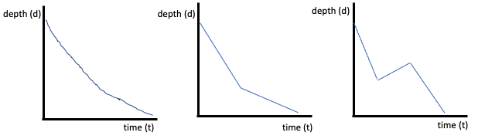
3. A ball is thrown in the air. Which of the following graphs do you not think is suitable to model the balls height against time.
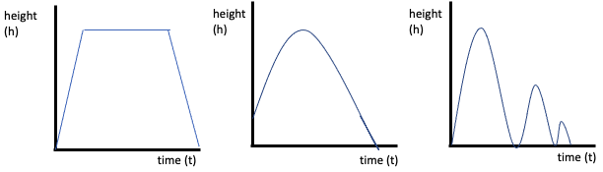

Exercise 10: Interpreting Models
1. Look at the table below.
Time | Temp
0 | 18
1 | 17
2 | 16.5
3 | 16
4 | 16.2
5 | 15
6 | 13.3
7 | 13
8 | 12.5
9 | 12.1
10 | 11.7
11 | 11.5
12 | 11.2
(a) Input the table into Excel
(b) Create scatter graphs to compare what type of model you think best fits the data.
(c) Write the equation of your line of best fit, give reason for your answer.

2. Look at the table below
a | b
1 | 0.678
2 | 0.841
3 | 0.991
4 | 1.133
5 | 1.34
6 | 1.448
7 | 1.651
8 | 1.7089
9 | 1.9501
10 | 2.111
11 | 2.0138
12 | 2.4481
13 | 2.65
14 | 2.78
15 | 2.93
16 | 3.092
17 | 3.261

(a) Input the table into Excel
(b) Create scatter graphs to compare what type of model you think best fits the data.
(c) Write the equation of your line of best fit, give reason for your answer.

3. Look at the table below
t | G
1 | 4.7
2 | 4.1
3 | 3.65
4 | 3.3
5 | 3.1
6 | 2.56
7 | 2.49
8 | 2.35
9 | 2.05
10 | 1.71
11 | 1.7
12 | 1.52

(a) Input the table into Excel
(b) Create scatter graphs to compare what type of model you think best fits the data.
(c) Write the equation of your line of best fit, give reason for your answer.

