Correlation

The questions below are taken from a textbook produced by Siyavula, which can be accessed here.

- For each of the following data sets, create a scattergraph, calculate the correlation coefficient and comment on the nature of the correlation, e.g., “strong positive”.
Note, the following command will create a list of data:
xa<-c(5,8,13,10,14,15,17,12,18,13)
  - 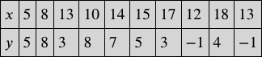
Scattergraph
Correlation coefficient
Correlation

  - 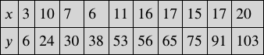
Scattergraph
Correlation coefficient
Correlation

  - 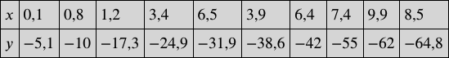
Scattergraph
Correlation coefficient
Correlation

  - 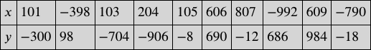
Scattergraph
Correlation coefficient
Correlation

  - 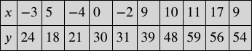
Scattergraph
Correlation coefficient
Correlation

- A geography teacher gave the data set below to his class to illustrate the concept that average temperature depends on how far a place is from the equator (known as the latitude). There are 90 degrees between the equator and the North Pole. The equator is defined as 0 degrees.
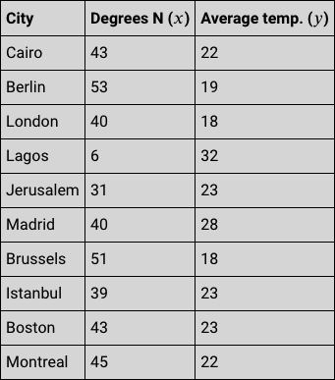
  - Create a scatter graph of this data, including a title and axis labels.

  - Determine the value of the correlation coefficient.

  - What can you deduce about the relationship between how far north a city is and its average temperature?

- A recording company investigates the relationship between the number of times a CD is played by a national radio station and the national sales of the same CD in the following week. The data below was collected for a random sample of 10 CDs. The sales figures are rounded to the nearest 50.
  - Create a scatter graph of this data, including a title and axis labels.

  - Determine the value of the correlation coefficient.

  - What can you deduce about the relationship between how many times a CD is played on the radio and the weekly sales of the CD?

Useful R commands

Entering data to R Studio To read in data from an Excel csv file called excel_data.csv to R Studio and name it mydata, first use the drop down menus in R Studio Session > Set Working Directory > Choose Directory to indicate the location of excel_data.csv on your computer. The following code will then read the data in to R Studio:

mydata<-read.csv("excel_data.csv")
attach(mydata) — this adds the variable names

At the end of the analysis remember to use detach(mydata) to disassociate the variable names.

(a) Graphics
plot(X,Y,xlab="x-axis label",ylab="y-axis label", main="Scatterplot of Y on X",pch=21,bg="black") — produces a scatterplot of X vs Y with black dots of the size specified by ‘pch’
(c) Correlation and Regression

cor.test(X,Y) — computes the correlation between X and Y and performs a test of the null hypothesis of zero correlation

