Higher Applications of Mathematics
Numerical and Graphical Representations – Questions similar to those found in AQA Core Maths.
- A maths exam has two papers. The two tables below show the percentage mark for 15 students for Paper 1 of the exam.
Student | A | B | C | D | E | F | G | H | I | J | K | L | M | N | O
% Mark | 92 | 80 | 67 | 96 | 72 | 59 | 91 | 82 | 51 | 71 | 49 | 74 | 70 | 83 | 64

- Give 2 words to describe what type of data this is.
Numerical and Discrete
- The table below shows information about the percentage marks for the same 15 students on Paper 2
 | Lowest Value | Lower Quartile | Median | Upper quartile | Highest value
Paper 1 | 49 | 64 | 72 | 83 | 96
Paper 2 | 45 | 70 | 73 | 85 | 92

Complete this table to show the information for Paper 2
- Draw two box plots to display this information.

- Compare the performances of the students in both the papers.
The average score for each paper is very close, but there is a greater spread of results for Paper 1
- Consumers of electricity have to decide which payment plan, or tariff to follow each year.
Tariffs usually consist of a charge per kilowatt hour (kWh) of electricity used and an annual standing charge.

The table below shows three tariffs that are offered to consumers.

 | Charge per kWh | Annual standing charge
Tariff A | 15p | £20
Tariff B | 13p | £50
Tariff C | 11p | £100

- Show that using 800kWh in on month of tariff B would cost £154.
50 + (800 x 0.13) = £154
- Draw 3 line graphs on the same axis to compare the 3 tariffs up to 3000kWh.
Coordinates for
Tariff A – (0,20) (500,95) (1000, 170) (1500, 245) (2000, 320) (2500,395) (3000, 470)
Tariff B – (0,50) (500, 115) (1000, 180) (1500, 245) (2000, 310) (2500, 375) (3000, 440)
Tariff C – (0,100) (500, 155) (1000, 210) (1500,265) (2000, 320) (2500, 375) (3000, 430)
- 24 Students in Year 9 each at national tests in Mathematics and English.
The back to back stem and leaf diagram shows their results.
Key 5 | 1 | 9 represents marks of 15 in Mathematics and 19 in English.
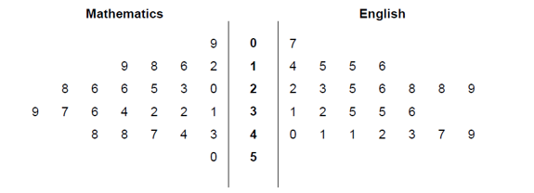
- The national average mark for the Mathematics test was 33.
Work out the percentage of these students who scored more than the national average in Mathematics.
10/24 = 42%
- The national average mark for English was 27.
How do these results compare with the national average? Show working to support your answer.
Mean = 29.917
The average of the class was slightly higher than the national average.

- The daily mean cloud cover for Leeming May-October 1987 is shown in the table below
Daily Mean Cloud Cover | Frequency
1 | 1
2 | 4
3 | 6
4 | 20
5 | 30
6 | 46
7 | 47
8 | 30
- What is the mode?
7
- What is the median?
6
- What is the mean?
6

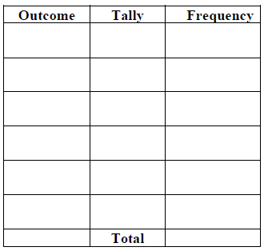
- A dice is rolled 20 times, giving the following result,
1 3 4 5 2 4 2 4 5 2 4 6 6 4 3 5 4 3 2 1
Record this data in a frequency table.

- The daily mean cloud cover for May 2015 from Leuchars is shown below
Daily mean cloud cover | Frequency
1 | 0
2 | 1
3 | 2
4 | $$c$$
5 | 3
6 | 6
7 | 5
8 | 4
The mean cloud cover is found to be $\frac{166}{31}$. Find the value of $c$.
10

- The daily mean air temperature for Perth in May 1987 is shown below
Daily mean air temperature (degrees, c) | Frequency
$$10≤c<13$$ | 4
$$13≤c<16$$ | 18
$$16≤c<19$$ | 7
$$19≤c<21$$ | 1
$$21≤c<24$$ | 1
- Find an estimate for the mean of this data

- Find the standard deviation for this data

