Histograms

A histogram is a type of bar chart used for continuous data. The data must first be grouped, and do not all need to be the same size.
A histogram features a title, labelled axes and bars of (potentially) variable width that touch, e.g.
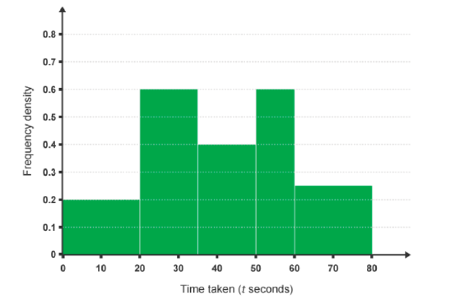

Example 1: Draw a histogram of the following.

Test Score | Frequency | Interval | Frequency Density
$$0<x ≤30$$ | 15 | 30 | 0.5
$$30<x≤40$$ | 22 | 10 | 2.2
$$40<x ≤50$$ | 28 | 10 | 2.8
$$50<x ≤70$$ | 30 | 20 | 1.5
$$70<x ≤100$$ | 9 | 30 | 0.3

The shape of the histogram illustrates the distribution (the shape of the data).
Data can be skewed, meaning it tends to have a long tail on one side and not the other.
We are going to look at each of these illustrations in terms of averages (mean, median) and spread (standard deviation and interquartile range).

Normally Distributed

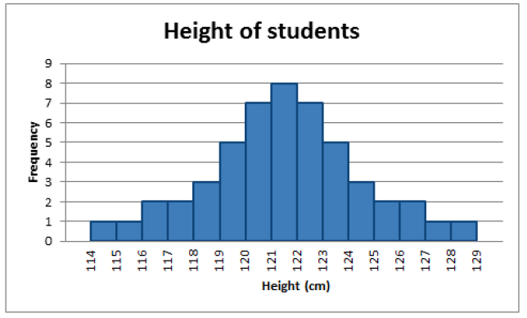

Normally distributed is the most important kind and the type that we will look and test for most frequently. Most of the results must sit in the middle of the graph with the least results at either side. When the line is draw it referred to as bell shaped.

Skewed to the Right

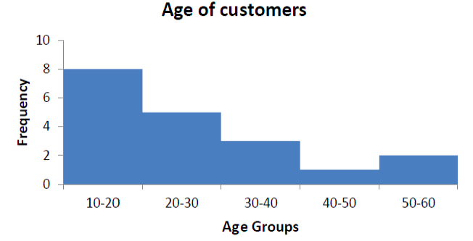
(Note how it goes the opposite way of what you would expect)

This is because the numbers on the right actually skew the mean and median to a higher number. This is why it is also called positively skewed.

Skewed to the left
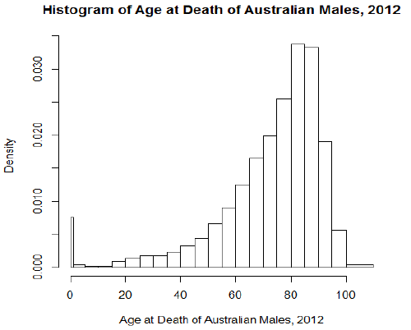

This is called skewed to the left because the data on the lower end of the graph will make the mean and median appear lower, hence it is also called negatively skewed.

Exercise: Draw the following histograms and decide if they are normal, skewed to the right or skewed to the left?

1.
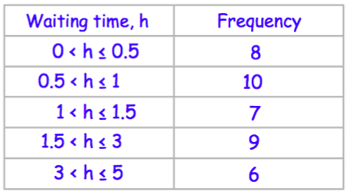

2.
Scores | Frequency
$$0<x≤20$$ | 4
$$20<x≤50$$ | 8
$$50<x≤75$$ | 10
$$75<x≤90$$ | 10
$$90<x≤100$$ | 15

3.
Attendance | Frequency
$$0<x≤60$$ | 12
$$60<x≤80$$ | 40
$$80<x≤120$$ | 90
$$120<x≤150$$ | 96
$$150<x≤180$$ | 65
$$180<x≤200$$ | 36
$$200<x≤250$$ | 60

4.
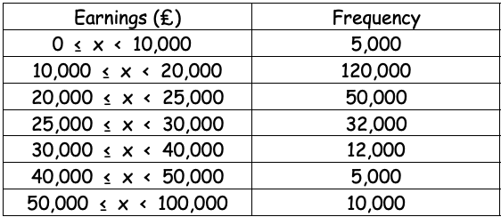

5. Sam asks some students how long they took to finish their science homework. The table and histogram show some of this information.
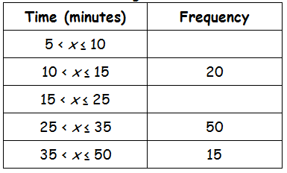

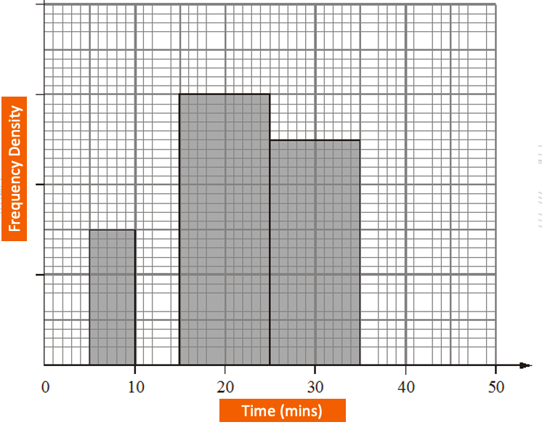
Complete the information in the table and histogram.

6. The table and histogram below give some information about how far some teachers travel to school.
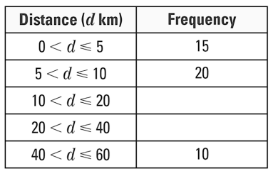
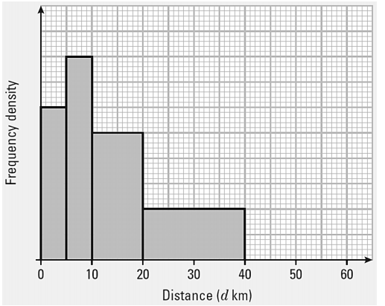

(a) Use the histogram to complete the table
(b) Use the table to complete the histogram

